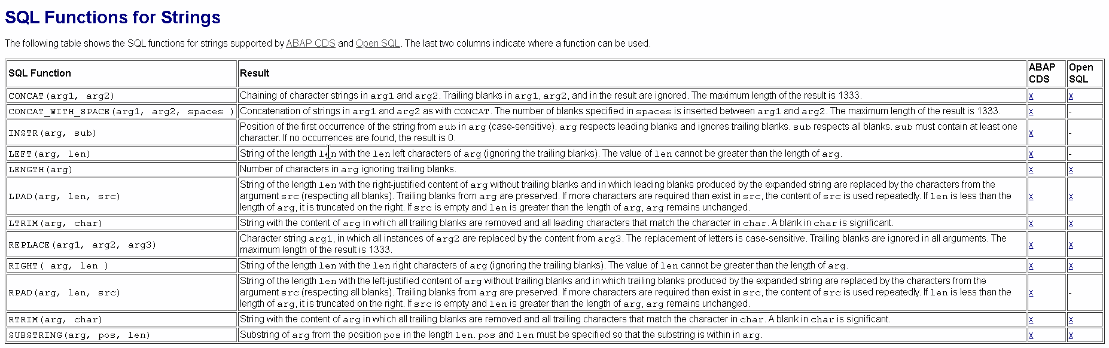

**String Functions in ABAP CDS Views**

Below is the list of frequently used string functions in ABAP CDS views.

**1CONCAT(arg1, arg2)**

**CONCAT(arg1, agr2)** string function can be used to concatenate two character strings.

@AbapCatalog.sqlViewName: 'ZCDS_STR_FUN'

@AbapCatalog.compiler.compareFilter: true

@AccessControl.authorizationCheck: #CHECK

@EndUserText.label: 'String Functions'

define view Zcds_Sql_Func as select from kna1 {

// CONCATENATE name1 & name2

CONCAT( kna1.name1, kna1.name2 ) as full_name

}

**2CONCAT_WITH_SPACE(arg1, arg2, spaces)**

This string function is used to concatenate two character strings with space. The number of blanks between the arguments *arg1* and *arg2* is specified in *spaces.*

@AbapCatalog.sqlViewName: 'ZCDS_STR_FUN'

@AbapCatalog.compiler.compareFilter: true

@AccessControl.authorizationCheck: #CHECK

@EndUserText.label: 'String Functions'

define view Zcds_Sql_Func as select from kna1 {

// CONCATENATE name1 & name2 with 4 space

CONCAT_WITH_SPACE( kna1.name1, kna1.name2, 4 ) as full_name

}

**3SUBSTRING(arg, pos, len)**

To get sub string of *arg* from the position *pos* in the lenght *len.*

@AbapCatalog.sqlViewName: 'ZCDS_STR_FUN'

@AbapCatalog.compiler.compareFilter: true

@AccessControl.authorizationCheck: #CHECK

@EndUserText.label: 'String Functions'

define view Zcds_Sql_Func as select from kna1 {

// To get substring for a given string

SUBSTRING( kna1.name1, 2, 10) as name

}

**4LENGTH(arg)**

It returns the no of characters in the string which is passed as a argument *arg.*It ignores trailing blanks.

@AbapCatalog.sqlViewName: 'ZCDS_STR_FUN'

@AbapCatalog.compiler.compareFilter: true

@AccessControl.authorizationCheck: #CHECK

@EndUserText.label: 'String Functions'

define view Zcds_Sql_Func as select from kna1 {

// To get length for a given string

LENGTH( kna1.name1 ) as name_length

}

**5LEFT(arg, len) & RIGHT(arg, len)**

**LEFT(arg, len)** – It returns the left-side part of the string which is passed as argument *arg* of length *len.*

**RIGHT(arg, len) –**It returns the right-side part of the string which is passed as argument *arg* of length *len.*

**Note:** Trailing blanks are ignored

@AbapCatalog.sqlViewName: 'ZCDS_STR_FUN'

@AbapCatalog.compiler.compareFilter: true

@AccessControl.authorizationCheck: #CHECK

@EndUserText.label: 'String Functions'

define view Zcds_Sql_Func as select from kna1 {

// To get length for a given string

LEFT( kna1.name1, 3) as name_left,

RIGHT( kna1.name1, 3) as name_right,

kna1.name1

}

**6LTRIM(arg, char) & RTRIM(arg, char)**

**LTRIM(arg, char) –**It removes the trailing blanks and leading character which matches the parameter *char.*

**RTRIM(arg, char) –**It removes the trailing blanks and trailing character which matches the parameter *char.*

@AbapCatalog.sqlViewName: 'ZCDS_STR_FUN'

@AbapCatalog.compiler.compareFilter: true

@AccessControl.authorizationCheck: #CHECK

@EndUserText.label: 'String Functions'

define view Zcds_Sql_Func as select from kna1 {

// Removes the trailing blanks and character

LTRIM( kna1.name1, 'L') as name_lt,

RTRIM( kna1.name1, 'T') as name_rt

}

Congrats! You have successfully learned **String Functions in ABAP CDS Views**.Please stay tuned for more ABAP CDS view tutorials.